***SYNOPSIS***

***ON***

***NFT GENRATOR***

***“creating generative abstract art-work using Python”***

***of***

***Bachelor of Technology***

***COMPUTER SCIENCE & ENGINEERING***

***BY***

***Karan Singh Bisht 19-CSE-45***



**DEPARTMENT OF COMPUTER SCIENCE & ENGINEERING**

**ECHELON INSTITUTE OF TECHNOLOGY, FARIDABAD**

**INDEX**

|  |  |  |
| --- | --- | --- |
|  | **Topic** | **Page no.** |
| **•** | **Introduction** | **3** |
| **•** | **Software and Hardware requirements** | **4** |
| **•** | **Conclusion** | **5** |
| **•** | **References** | **6** |

**INTRODUCTION**

**This NFT Generator allows the user to create up to three completly unique assets folder with no duplicated NFTs. In addition, NFTs can be randomized.you can test the rarities of your attributes without generate any NFT, because generating NFTs takes some time . WE can genrate diffrent pieces of art with it.**

## **We can mint these nft then on open sea it is a very wide market place for it. creating generative abstract art-work using Python.**

#### **Genrative ART**

#### 

**SOFTWARE REQUIREMENT & LANGUAGES USED**

**1.SOFTWARE SPECIFICATION USED:**

**Visual Studio Code (for writing code)**

**An terminal to run the commands.**

**python3 resart.py -n 32 --collection "foo"**

**Generates a collection called 'foo' with 32 pieces into ./output/foo/**

**Digitals assets are needed simple colours and etc**

**we need pillow library**

**pip install pillow**

**2. PROGRAMMING LANGUAGES USED**

**Python3 programming language**

**step 1 : pip install pillow**

**step 2 : python3 resart.py -n 32 --collection "foo"**

**CONCLUSION**

**This application program does not collect any additional data of the user; Hence it is safe and secure. It provides faster and flexible user-device interface medium. User don’t need to login or sign up in order to use this software program. It is fun and easy way to earn some extra money you can also mint these nfts in opne sea or binance nft .**

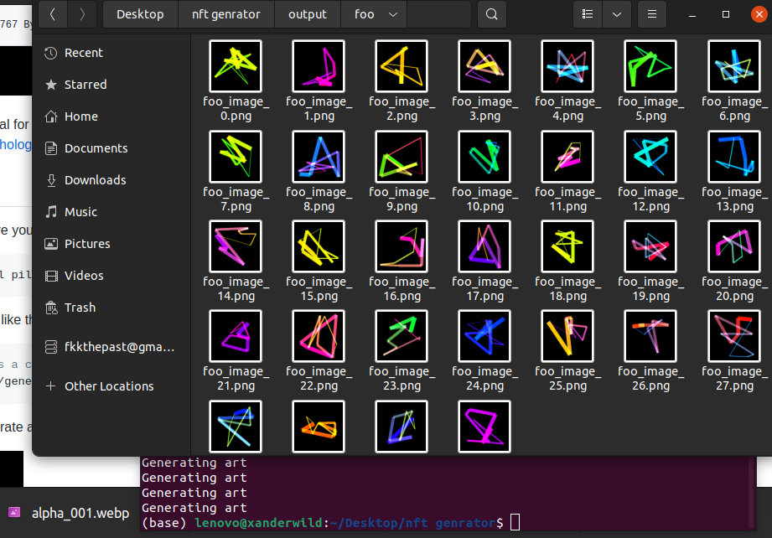

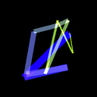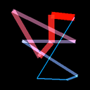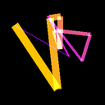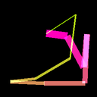

**creating generative abstract art-work using Python**

**REFERENCES**

**\***[**https://nftschool.dev/**](https://nftschool.dev/)

**\***[**https://www.fool.com/investing/stock-market/market-sectors/financials/non-fungible-tokens/how-to-make-an-nft/**](https://www.fool.com/investing/stock-market/market-sectors/financials/non-fungible-tokens/how-to-make-an-nft/)

**\*https://www.youtube.com/watch?v=3WBjT1B65AM**

**\*https://www.youtube.com/watch?v=BMq2Jrvp9AA**